

Merchandise

Order Form

Prices and products are subject to change without notice. For current pricing, visit our website at http://www.senderosoftware.com or you may contact us at sales@senderosoftware.com

Demographics:
Company
First Name:
Last Name:
Address:
Address (line 2):
City:
State/Province:
(USA or Canada)
Region:
(Outside USA and Canada)
ZIP/Postal Code:
Country:
Phone:
Fax:
Web Site Address:
E-mail:

Product Description: QTY Sub-Total
DBF-Desktop Professional v.1x (license required for each install) $39.00
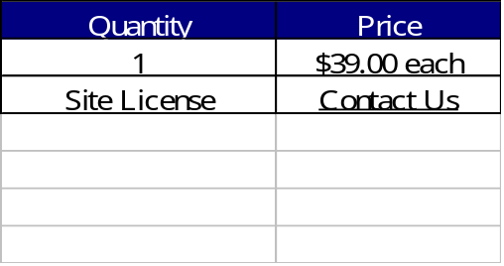

TOTAL
Payment Options:
Credit Card customers may use our online ordering system on main site: http://www.senderosoftware.com
Check (US Bank) #
(Make checks Payable to Sendero Software)
International Money Order (in U.S.) Purchase Order #
Questionnaire:
Where did you hear about our products?

